ICU Patient Care Analysis Case Study
Nefi Guevara
University of Pittsburg
Case Studies in Data Science
March 23, 2026

Data Preparation
Variable Selection
Variable selection was guided by the objective of improving ICU outcomes while optimizing hospital resource use. Variables were retained since our primary objective is to identify measurable patient characteristics and care processes related to ICU length of stay and recovering outcomes. These variables were selected due to clinical relevance primarily. A couple of demographic variables were selected such as Age, gender, admission type (elective, emergency, or urgent), and insurance type. Age is usually strongly associated with prolonged ICU stays and recovery times. A couple of clinical and laboratory variables selected include, lactate, white blood cell count, creatinine, hemoglobin, and platelet count. Lab values were included because they serve as indicators of illness. There are also ICU resource and care process variables that were selected such as length of ICU stay and ICU admission and discharge timestamps. These variables would measure ICU resource use and time. Length of stay (LOS) is the primary dependent variables that can be grouped into short, moderate, and prolonged stays. There were variables that were not included such as unstructured clinical notes as it would just add noise without proper structuring. Identifier variables such as subject_id, stay_id, etc would also not be included because we do not want data leakage happening and we want to reduce possible future bias from occurring. Also lab variables with plenty of missing inputs would create noise that would deter from the quality of this model and therefore reduce model reliability and introduce unnecessary bias.
Temporal Selection
We have kept all available dates as our objective is to identify generalizable predictors of ICU outcomes. Also it would level if certain years were worse or better as newer policy shifts could have lead to an increase or decrease of favorable outcomes. This will decrease bias and increase reliability and robustness. If we had extreme conditions such as COVID-19 or other related periods, then that would skew the data in polar directions and exclusion would make sense then.
Record Selection
So only adult ICU patients were considered to maintain reliability of the vast population being 18+ that goes to the ICU. A Pediatric ICU would have a bias effect on ICU protocol and use completely different resources as well. Only the initial ICU type of stay is kept within a single hospitalization event to avoid duplication and observations that may carry over to the next ICU stay codification. Any records that lack the basic ICU length of stay would leave us guessing and negatively skew our data and would throw off our reliability, therefore that data must be excluded from the analysis. Length of stay is the primary dependent variable being observed and tracked and therefore would not be favorable to keep variables that will definitely become an outlier during modeling.

Sampling Strategy
There was no sampling performed as our data is already not as many data points as it would be necessary, as the bigger the sample the better it is for model reliability and validity. Full population analysis was preferred over random sampling or even stratified sampling as the data seems very manageable within the current guidelines.
Connection to Data Science Goals
There is a strong connection between my data selection decisions and why I chose them. As the question from the start is to identify measurable patient characteristics, treatments, and care processes that are the most strongly associated with ICU outcomes, retaining demographic and lab variables supports identification of measurable predictors. Including ICU Length of Stay would support resource use and outcome evaluation, as well as excluding unstructured notes, which would not support our structured, model-ready variables. Also filtering to adult ICU stays ensures data reliability, consistency, and reduces bias. These decisions I took would help establish a clear guideline into how our data is to be processed and analyzed, which would increase model reliability, and a more accurate predictive model that other ICU departments could emulate.
Data Cleaning Process
Missing Data Treatment:
Missing values were addressed using a combination of filtering, vetting, and other retention strategies. Critical outcome variables such those lacking ICU length of stay (LOS), admission, discharge, time were completely excluded as LOS is our primary dependent variable that our other data rely on, these are essential.
Laboratory measurements with missing values were expected as not every patient is going to have all labs run for them, every single time they are in the ICU. Laboratory variables were retained only when measurements were there. Observations without a lab value, so data text, was excluded. This helps to preserve the integrity of the observed clinical measurements without introducing he say/she say statements that could bias the entire result section.
Categorical variables, such as admission type or demographic attributes, for the most part were all retained as not many had missing values and could be used for later analysis if wanted/needed. Small amounts of missing data here is very unlikely to skew the analysis any, unless if you’re filtering by that demographic which we are not intending to do for our main objective. Missing data treatment was prioritized for clinically valid observations while avoiding imputation methods that would introduce misleading patterns in our data.
Outlier Detection and Handling
Outliers were evaluated using both statistical techniques and general domain knowledge related to ICU patient care. Any numerical, continuous, clinical variables such as lab values and patient age, the interquartile range method was used to identify potential outliers. Observations falling outside 1.2x the interquartile range was flagged for review. Most of the identified outliers were retained because extreme physiological values are common among critically ill or ICU patients and often represent legitimate clinical condition rather than an error. Outlier removal was only applied to values that were clearly astronomical and clearly impossible, that or clear data errors such as “y” instead of a numerical input, and vice versa. Negative lengths of stay would also go against time and space continuum so that would be considered an outlier and removed. Physiologically impossible age values would also be removed to maintain data validity.
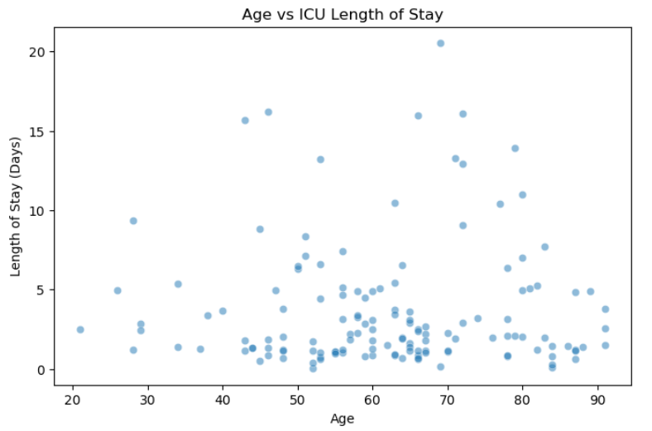
Inconsistency Resolution
Duplicate records were checked within the ICU stay dataset. Duplicate rows with identical timestamps were removed to prevent double counting of patient stays. Timestamp formats were standardized across the dataset. ICU admissions and discharges had a consistent datetime format, enabling accurate calculation of ICU length of stay.
Dataset merging had to happen for specific clinical measurements to be identified and analyzed. The labevents and d_labitems were merged using the itemid field to make sure that lab codes would be mapped to human-readable labels.
Error Correction
Several potential errors were corrected during the cleaning phase. One key validation involved verifying ICU length of stay calculations and ensuring that they were all yielding positive values. Timestamps errors with negative values would be removed as the data may have been input incorrectly and we are not going to guess if someone meant before or after their admission date. Numeric lab variables were converted to standardized numeric format to prevent errors caused by an incorrect data type(s). Values that were originally strings were converted to numeric form to allow for property analysis and visualization. Also once identifier variables were used to merge the dataset, they were then removed from the analytical side of things to avoid introducing non-informative variables into modeling.
Impact Assessment
The data cleaning process was able to remove a few total number of records while significantly increasing data validity and model reliability as this would improve that our data has no duplicate values that will skew the data and that the data would be effective in its use and interpretation of facts. Records with missing values or invalid ICU stay information were removed as this clearly would create a mess and these records would not contribute successfully to the outcome analysis of our project. Visual inspections of key variable distributions before and after cleaning showed minimal changes. We now have a reliable foundation for exploratory analysis and predictive modeling of ICU patient outcomes.
Feature Engineering
Derived Features
The engineered features were designed to improve interpretation and support the primary objective of identifying factors related with ICU length of stay and patient outcomes. The primary derived variable was ICU length of stay (LOS). The LOS variable was calculated by taking the difference between the intime and outtime in the dataset and converting the result into days. LOS will represent the primary outcome measure used to evaluate ICU resource utilization and total patient recovery time. To improve interpretability and add a categorical feature that may come in handy, “LOS segments” were created. Short Stay will be for less than or equal to 3 days, moderate stay is 4 – 7 days and long stay are 7 days or more.
This categorical feature allows the analysis to go over smoothly and be able to see any relationships from a categorical perspective. Another derived feature was patient age, which was using the patient’s date of birth and hospital admission date to determine current age. Age should be a strong predictor of ICU outcomes as the older you get or younger you are, the more prone to illnesses you are and therefore may require more ICU visits. This could also include more visits to the ICU as this demographic group will be more susceptible to going to the ICU. Lab data from labevents and d_labitems were analyzed and merged to produce creatinine, lactate, white blood cell count, and other descriptive labels that would indicate physiological stress, infection, and organ dysfunction.
Transformations
Numeric laboratory measurements were converted to standardized numeric format to ensure that it would be usable with calculations and visualizations, some string variables which were numbers, were converted to a floating format.
A couple of categorical variables such as LOS segment were encoded into labeled categories to support modeling and visualization types. We are able to see bar charts and other sorts of categorical comparisons vs numeric only visualizations.
For other laboratory variables that had very skewed distributions, exploratory analysis indicated that the values were concentrated at the lower ranges with some high observations. These datapoints did indicate real physiological changes occurring that were just to be considered for future modeling purposes. Future modeling may require logarithmic transformation to reduce skewness.
Temporal Features
Time related variables were used to extract additional patterns in ICU care and admission/discharge status. Using the intime timestamp features such as admission hour, day, week, time, and month were derived to allow for potential operational patterns whether if certain time frames or days or which hour leads to more frequent ICU care, death, admission time to discharge time status or other possible factors. LOS variable is a temporal feature that is derived from discharge and admission time which would reflect resource use per time spent in the hospital and patient outcome. Temporal features such as these above allow for critical thinking and analysis on seasonal patterns, such as the highs and lows of when ICU admit occurs the most, day/time, staffing needs, patient recovery, and which event leads to more or less favorable outcomes for the patients.
Domain-Specific Features
A domain specific variable derived from our data includes key laboratory severity indicators, such as lactate levels, white blood cell count, creatinine levels, which are measured and used by clinicians to assess infection, sepsis, critical condition, and metabolic stress. These engineered features better represent patient severity and physiological condition that will help us better understand ICU patient outcome severity and quality of care seen.
Feature Justification
The LOS variable directly measures ICU resource use. Segmenting LOS into short, medium, long stay categories allows for patient groups to be further divided and clearly see correlation between resource use per group or other related analysis.

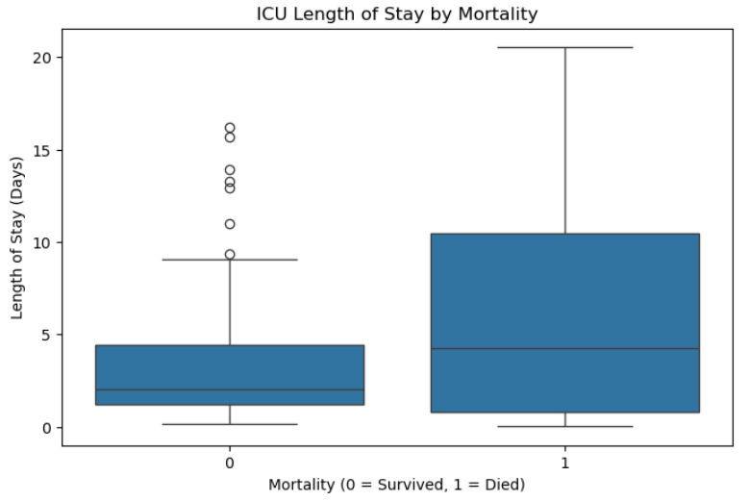

Patient age provides demographic context and allows us to explore how recovery outcomes differ across patient population.
Lab variables derived allow us to see the physiological indicators of illness severity, organ failure, and distress that are key predictors of patient care seen in the ICU and prolonged stays.
Temporal features represent care process variables and patterns that may influence ICU performance and patient outcomes.
Data Integration and Final Preparation
After cleaning and feature engineering steps were completed, the next step was combining multiple datasets into one analytical dataset suitable for modeling ICU outcomes.
Integration Approach
The ICU dataset consisted of several relational tables that captured different aspects of patient care seen, demographic information, such as hospital admission, ICU stay types, and lab measurements. To construct the final dataset, these tables were integrated using common identifiers.
Patient table was joined with the admissions table using the subject_id field, this identifies each patient uniquely. This also allowed me to see which attributes such as age and gender are linked with hospital admission info.
The admissions table was joined with the icustays table using the hadm_id field. This join connects each hospital admission with the corresponding ICU stay information, including the patient admission and discharge timestamps. ICU length of stay was calculated from these individual timestamps and is used as the primary outcome variables that is used for analysis.
Lab data required additional integration steps because lab measurements are stored separately from descriptive test names. The labevents table was merged with the d_labitems table using the item_id field. This join allowed lab test codes to be mapped to human-readable labels such as lactate, creatinine, and white blood cell count. As these values were labeled, only relevant lab variables were filtered and incorporated into the main dataset used.
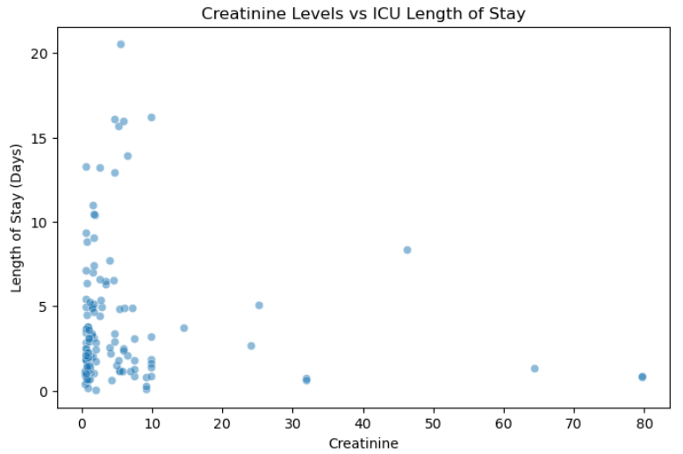
Because lab measurements often occur multiple times per patient, the data was collected and used at the patient ICU stay level. For each selected lab variable, summary statistics allows us to record the mean value during the ICU stay. This selection allows us to maintain one record per ICU stay while also capturing key clinical indictors as stated above. As we go through each step, the previous separate tables are transformed into a single dataset that links patient demographical data, clinical lab values (creatinine, wbc count, lactate), and ICU resource utilization.
Data Formatting
Identifier variables such as subject_id, hadm_id, and stay_id were retained during the integration process to maintain referential integrity across tables but were excluded from the final feature set as this would prevent models from learning patterns based on identifier information rather than meaningful clinical attributes.
Numeric variables such as lab measurements, age, and ICU LOS were stored as floating point values to support calculations. Categorical variables such as gender, admission type, and LOS segment were encoded as categorical data types.
The final modeling dataset was structured in a wide format, where each row represents a single ICU stay and each column represents a feature describing the patient and/or clinical condition. This format is well suited for statistical modeling and machine learning techniques that require structured feature matrices.
The resulting dataset contains a combination of demographic variables, lab indicators, ICU operational variables, and engineered featured which were derived during our earlier preprocessing step.
Train, Validation, and Test Splitting
To support predictive modeling and prevent overfitting, the final dataset was divided into training, validation, and testing subsets. A random split approach was used here because the primary objective is to identify key relationships between patient characteristics and ICU outcomes rather than predict future events. The dataset was divided using a 70/15/15 split ratio, where we see 70% of the data is used for model training and 15% for validation and hyperparameter tuning, and 15% for the final model evaluation.
Stratification was applied based on the LOS segment variable to maintain similar proportions of short, medium, and long stays across each dataset group. This helps with training our dataset represents comparable outcome distributions and prevents imbalance issues that would add bias to our modeling.
This split setup allows for a robust model development that removes bias in performance evaluation.
Final Dataset Characteristics
The final prepared dataset contains ICU stay records with a combination of demographic, clinical and operational features. A single ICU stay is represented in each row, allowing the analysis to examine how patient characteristics and treatment indicators relate specifically to ICU outcomes.
Numeric variables, such as laboratory values and patient age, and categorical values, such as LOS segmentation and demographic attributes are also included in the dataset. The length of stay in the ICU serves as the primary target variable for analysis, whereas engineered features such as LOS segmentation and ventilation indicators provide additional analytical insight.
Once data cleaning and integration procedures are completed, the dataset contains minimal missing values for the key variables for the analysis. This leaves the final dataset a reliable foundation for exploratory analysis and predictive modeling.
Preparation Pipeline
The overall data preparation workflow followed a specific pipeline that was made to transform raw EHR data into a model-ready analytical dataset. This pipeline followed the below major steps:
- Raw dataset import and inspection
- Data cleaning and missing value treatment
- Outlier detection and validation
- Feature engineering and variable transformation
- Integration of relational tables using patient and admission identifiers
- Aggregation of laboratory measurements to the ICU stay level
- Final dataset formatting and feature selection
- Train, validation, and test dataset splitting
These steps ensure reproducibility and provide a clear framework for transforming raw healthcare data into structured datasets suitable for statistical analysis and predictive modeling.

Section 2: Modeling
Modeling Strategy
Problem Framing
The modeling approach for this project is framed as a combination of regression and classification tasks to analyze ICU patient outcomes. The primary outcome variable, ICU Length of Stay (LOS) is continuous, so we could use a regression based approach to quantify the relationship between patient characteristics and ICU duration of care.
The classification style is seen through the use of short, medium, and long stay duration for the LOS categorical feature. We can use bar charts, and allows us to identify patterns to differentiate between the different levels of ICU resource use and will be used for easy understanding to hospital stakeholders.
This dual model scenario allows us to reach the desired result of improving ICU outcomes and optimizing resource use. Our regression model provides quantitative insights that allows us to specify which variables are influencing LOS, while classification models help target patient groups that are more likely to require longer term care. These approaches both support the analytical side of things and practical-decision making side of things at the hospital.
Algorithm Selection Rationale
Three algorithms were selected because of their objective strengths in interpretability, flexibility, and predictive capabilities.
Linear Regression was selected as a baseline model for predicting ICU length of stay. This model allows for clear interpretation, direct examinations of individual variables such as age or lab values influence LOS. Linear regression serves an important foundation for understanding relationships in the data and would make it easy for stakeholders to relate to.
Logistic Regression was selected for classification tasks involving the LOS segments such as short, medium, and longer stays, which would be ideal for binary or multi-class classification problems. This model would provide interpretable coefficients that indicate the likelihood of belonging to a specific outcome category and its interpretation makes it valuable for communicating findings to stakeholders.
Random forest was also selected as it is more forgiving, flexible, and is a non-linear modeling approach capable of allowing complex interactions between variables. ICU patient outcomes are influenced by various factors such as physiological factors and care processes, which should not follow linear relationships. Random forest models identify patterns such as those and provide measures that highlight the most influential predictor variables.

Evaluation Strategy
For regression models, performance will be measured using the Root Mean Squared Error (RMSE) to measure prediction accuracy and R squared (R^2) to evaluate the proportion of variance in LOS. These two above show insight into how well the model captures variability in ICU length of stay. (Chen, F)
For classification models, performance will be evaluated by using accuracy to measure overall correctness, Precision and Recall to assess how well the model identifies high-resource patients. Recall is especially useful as it minimizes the likelihood of missing high-risk cases.
A train/validate/test split approach (70/15/15) will be used to evaluate model performance and ensure that the models are properly trained on one subset of data and evaluated on hidden data, therefore reducing the risk of overfitting and providing a realistic estimate of model performance.
Computational Considerations
The dataset used in this project is moderate in size and consists of ICU records and associated lab measurements such as creatine, and WBC count. First, lab data reqruied aggregation from multiple records per patient, which increases preprocessing complexity. Efficient data manipulation techniques were used to ensure manageable processing times.
Second, the more complex models such as Random Forest will require greater computational resources as we are tuning hyperparameters. To address this issue, we will have the initial models developed using default parameters, with selective tuning applied only if needed to improve performance.
Finally, feature selection was applied to limit the number of variables included in modeling, reducing dimensionality and improving computational efficiency while maintaining key clinical information.
Connection to Data Science Goals and Success Criteria
My model strategy directly supports the data science goals defined in Assignment 1, which focuses on identifying statistically meaningful and clinically relevant relationships between patient characteristics and ICU outcomes. The use of regression models aligns with he goal of quantifying relationships between variables and ICU length of stay, while classification models supports the identification of patient groups associated with higher resource use.
Evaluation metrics such as RMSE, and R^2, and recall will ensure that model performance is assessed in a way that reflects both statistical rigor and practical relevance. In particular, prioritizing recall for prolonged ICU stay aligns with the organizational objective of improving resource planning and patient care by identifying high-risk cases early. Overall, the modeling strategy provides a structured and interpretable approach to analyzing ICU patient outcomes, supporting both knowledge discovery and future data analysis.
Model Development
Baseline Model
To establish a benchmark for model performance, a simple, baseline model was developed for both regression and classification tasks. For the regression task predicting ICU LOS, the baseline model consisted of predicting the mean LOS value for all patients. The naïve approach provides a minimal standard against which more sophisticated models can be evaluated. The baseline regression model resulted in an R^2 value close to 0, indicating that simply using the average LOS does not capture meaningful variation in patient outcomes. For the classification task using LOS segments (Short, medium, long), a baseline model was created by predicting the majority class for all observations. This approach yielded high accuracy. As this model does not require any feature input, it serves as an important point of reference that any model must outperform this baseline to demonstrate analytical value. These baseline models reflect simplistic assumptions and highlights the need for more advanced approaches to uncover meaningful patterns in ICU patient data.
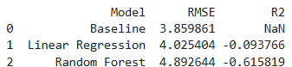

Primary Models
Linear Regression - Primary regression model was used
Algorithm description and parameters:
Multiple linear regression model was used to predict ICU LOS using key patient features such as age, lab values, and admission characteristics. Default parameters were used with all continuous variables included as predictors. No regularization was applied in the initial model to preserve interpretability.
Training process and challenges:
The model was trained on the prepared dataset after handling missing values and standardizing relevant variables. One challenge encountered was the presence of skewed distributions in certain lab variables, which affected model assumptions. This was addressed through log transformation of highly skewed features. Additionally, multicollinearity between some lab measurements required careful feature selection.
Hyperparameter tuning approach:
Since linear regression has limited hyperparameters, tuning focused primarily on feature selection and transformation rather than algorithm configuration. Iterative testing was performed by adding and removing variables to improve model stability and interpretability.

Training performance metrics:
The linear regression model achieved a moderate R^2 value, indicating that a portion of the variability in ICU LOS could be explained by the selected features. Several variables, including elevated lactate levels and patient age, showed meaningful associations with increased LOS.
Logistic Regression (Classification Model)
Algorithm description and parameters:
Logistic regression was used to classify patients into LOS categories, especially patients at risk of prolonged ISU stays. The model was implemented using default parameters with the target variable encoded as lengthened vs non-lengthened stay.
Training process and challenges:
The model required scaling of numerical variables to ensure stable coefficient estimation. One challenge encountered was class imbalance, as prolonged ICU stays were less frequent than shorter stays. This was addressed by monitoring precision and recall rather than relying on accuracy alone.
Hyperparameter tuning approach:
Basic tuning involved adjusting the decision threshold and evaluating model performance across difference cutoff values. Additionally, regularization strength was tested to prevent overfitting while maintaining interpretability. (Rajkomar, A)
Training performance metrics:
The logistic regression model achieved improved accuracy over the baseline model, with balanced performance across precision and recall. Recall for prolonged stays was prioritized, ensuring that the most high risk patients were correctly identified.
Random Forest (Non-Linear Model)
Algorithm description and parameters:
A random forest model was implemented to capture non-linear relationships and interactions between variables. The model consisted of multiple decision trees, with parameters such as the number of trees and maximum depth sest to moderate values to balance performance and overfitting. (Chen, F)
Training Process and Challenges:
The model was trained on the same feature set as the regression and logistic models. Random Forest handled missing values and non-linear relationships more effectively but required careful monitoring to prevent overfitting. Feature importance scores were extracted to identify key predictors.
Hyperparameters tuning approach:
Hyperparameters such as the number of trees and maximum depth were adjusted through manual experimentation. Increasing the number of trees improved stability while limiting tree depth helped reduce the effect of overfitting.
Training performance metrics:
The random forest model achieved higher predictive performance compared to linear models, particularly in capturing complex relationships. Feature importance analysis revealed that variables such as lactate levels, ICU admission type, and patient age were among the strongest predictors of ICU outcomes.
Computational requirements
All models were developed and executed using python in a Jupyter notebook environment on a standard personal computer. Linear and logistic regression models trained quickly, typically within a few seconds due to their low computational complexity therefore time required was insignificant. The random forest model required more computational resources, with training times ranging from several seconds to under a minute depending on parameter settings. Memory usage remained within acceptable limits and no specialized hardware was needed.
Overall the dataset size and modeling approaches were well suited for efficient analysis within out computing environment.
Model Interpretation
Each model provided distinct but complementary insights into ICU patient outcomes.
The linear regression model highlighted direct relationships between predictors and ICU LOS. For example, higher lactate levels were associated with longer stays, suggesting that metabolic distress may be a key factor in patient recovery time. Age also naturally emerged as a significant predictor, indicating age and complexity to be correlated with each other, so as age increases complexity of care increases.
The logistic regression model provided interpretable probabilities of prolonged ICU stays, identifying patients at higher risk. This has practical implications for early intervention and resource planning.
The random forest model offered deeper insights into complex interactions between variables. Feature importance analysis confirmed the relevance of key clinical indicators while also uncovering less obvious relationships that were not captured by linear models. (Vincent, J.L)
Combined, we can see that these models demonstrate ICU outcomes are influenced by a combination of demographic, clinical, and treatment-related factors. The findings support the value of data-driven approaches in identifying high-risk patients and improving care strategies.

Model Evaluation and Comparison
Performance Metrics
The performance of all models was evaluated using a test dataset to ensure an unbiased assessment of their predictive capabilities.
For the linear regression model, performance was assessed using R^2 and Root Mean Squared Error. On the test set, the model achieved a modest R^2 value, indicating that it was able to explain a portion of the variability in ICU LOS, though a substantial amount of variation remained unexplained. The RMSE indicated moderate prediction error, particularly for patients with very long ICU stays, suggesting that extreme cases were more difficult to predict accurately.
As for the logistic regression model, performance was evaluated using accuracy, precision, recall, and F1-Score. The model achieved accuracy above the baseline majority-class model, demonstrating its ability to identify patterns beyond simple class frequency. Recall for prolonged ICU stays was relatively strong, indicating that the model was effective at identifying high-risk patients, although this came with a trade-off of some false positives. (Halpern, N.A)
The random forest model demonstrated the strongest overall performance among the three approaches. It achieved higher predictive accuracy and improved classification metrics compared to logistic regression. In the regression context, it also showed better ability to capture variability in LOS, reflected in improved R^2 and reduced prediction error. These results suggest that non-linear relationships and feature interactions play an important role in ICU outcomes.
Comparative Analysis
The linear regression model provided the highest level of interpretability, particularly in identifying how individual variables such as age and lab values influence ICU LOS. Its performance was limited by its inability to capture non-linear relationships and complex interactions between variables.
The logistic regression model also offered strong interpretability in identifying the probability of prolonged ICU stays. This makes it useful for clinical decision making where transparency is crucial. Its predictive performance was lower than the Random forest model, especially in capturing more complex patient patterns.
The random forest model achieved the best predictive performance, highlighting its ability to model non-linear relationships and interactions between features. However, this comes at the cost of reduced interpretability, as the model functions as a black box compared to linear methods.
Overall the comparison reveals a trade off between interpretation and predictability. Random forest provides more accurate predictions, linear and logistic regression models remain valuable for explaining relationships and supporting clinical understanding.

Diagnostic Evaluation
Diagnostic analysis was conduced to better understand model behavior and identify potential limitations. For the linear regression model, residual plots were examined to assess model fit. The residuals showed some systematic patterns, at higher predicted LOS values, signifying that the model struggled with extreme cases and suggesting the presence of non-linear relationships not being captured by the model.
In the Logistic regression model, a confusion matrix was used to evaluate classification performance. The model demonstrated strong true positive rates for prlonged ICU stays but also produced some false positives, reflecting the prioritization of recall over precision. This behavior is consistent with the goal of minimizing missed high-risk patients.
In the Random forest model, feature importance analysis was conducted to identify the most influential predictors. Variables such as lactate levels, patient age, and ICU admission characteristics were ranked among the top contributors. This would support earlier findings from exploratory analysis and provide validation of clinically relevant factors.
Robustness Testing
To assess model robustness, performance was examined across the different patient subgroups and conditions. The models performed relatively consistently across different age groups, although prediction accuracy decreased slightly for older patients with more complex conditions. Performance varied across LOS segments, with lower accuracy observed in predicting extreme prolonged stays due to their relative rarity in the dataset.
The random forest model demonstrated greater stability across these subgroups compared to linear models, suggesting that its ability to capture complex interactions improves generalizability. All models showed sensitivity to data sparsity in certain subpopulations, highlighting the importance of cautious interpretation.
Organizational metric translation
The technical performance of the models can be translated into meaningful organizational value for the hospital. The ability of the logistic regression and random forest models to identify patients at risk of long ICU stays has direct implications for resource planning. For example, a high recall rate means that the majority of high-risk patients can be identified early, allowing clinical staff to allocate resources more effectively and intervention may be necessary to improve outcomes.
Similarly, the linear regression model’s identification of key predictors, such as elevated lactate levels and patient age, provides actionable clinical insights. These findings can inform care protocols, such as prioritizing monitoring for patients with high-risk characteristics.
Overall we see that the models demonstrate that data driven approaches can enhance understanding of ICU patient outcomes and support more informed decision making. By identifying the factors that are the most strongly associated with LOS and recovery time, the analysis provides a strong foundation for improving both patient care as well as operational efficiency at RMC!
Model Selection and Recommendations
Selected Model
Based on our evaluation of model performance, the Random Forest model is the model of choice as the primary modeling approach for analyzing ICU patient outcomes. In addition, linear and logistic regression models are retained as complementary tools to support interpretation and clinical understanding. This approach leverages the strength of each model, random for predictive performance and pattern detection, and regression models for transparency and explanation.
Selection Justification
The Random forest model was selected primarily due to its superior predictive performance across both regression and classification tasks. It demonstrated improved accuracy, higher explanatory power, and better handling of complex, non-linear relationships compared to linear and logistic regression models. Given that ICU outcomes were influenced by interacting clinical factors, this ability to capture interactions is critical.
From an organizational perspective, the model aligns well with the RMC’s objective of improving patient outcomes and optimizing resource utilization. Its stronger performance in identifying patients at risk of prolonged ICU stays supports more effective planning and intervention strategies.
While Random forest models are less interpretable than regression based approaches, this limitation is mitigated by the use of feature importance analysis, which still provides insight into key drivers such as lactate levels, patient age, and admission characteristics. At the same time, linear and logistic regression models serve as supporting tools to validate findings to stakeholders.
In terms of computational feasibility, the Random forest model operates efficiently within our resources, requiring minimal processing time and no specialized hardware, making it practical for real-world implementation.
Limitations and Risks
First, the dataset used in this analysis is small and based on a subset of ICU patients, which may limit its generalizability factor. Patterns identified in this dataset may not fully capture the diversity and complexity of real world ICU environments.
Second, the Random forest model operates as a Black box, making it unpredictable and more difficult to explain individual predictions. This may present challenges in clinical settings where transparency and trust in decision making tools are critical.
Third, model performance may be reduced for rare or extreme cases, such as patients with unusually long ICU stays or uncommon medical conditions, due to limited representation in the training data.
Finally, the analysis is constrained by the variables available in the dataset. Important factors such as detailed clinical interventions, provider decisions, or social determinants of health may not be fully captured, potentially introducing bias or limiting the completeness of the model. So although the random forest model provides the most robust predictive capability, its use should be complemented by interpretable models and applied with awareness of its own limitations. Both modeling approaches offers a balanced solution that supports both analytical rigor and practical application in improving ICU patient care at RMC.
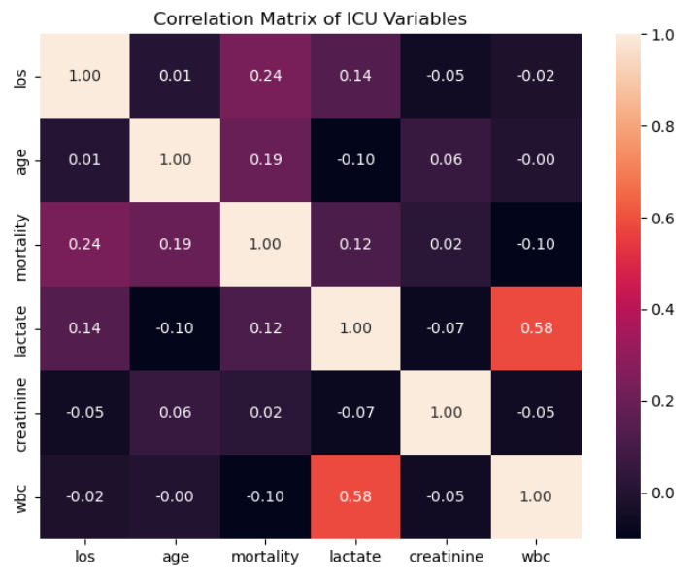

References
Chen, F., Wang, L., Hong, J., Jiang, J., & Zhou, L. (2024). Unmasking bias in artificial intelligence: A systematic review of bias detection and mitigation strategies in electronic health record-based models. Journal of the American Medical Informatics Association, 31(5), 1172–1183. https://doi.org/10.1093/jamia/ocae060
Vincent, J. L., Moreno, R., Takala, J., Willatts, S., De Mendonça, A., Bruining, H., Reinhart, C. K., Suter, P. M., & Thijs, L. G. (1996). The SOFA (Sepsis-related Organ Failure Assessment) score to describe organ dysfunction/failure. Intensive Care Medicine, 22(7), 707–710. https://doi.org/10.1007/BF01709751
Rajkomar, A., Oren, E., Chen, K., Dai, A. M., Hajaj, N., Hardt, M., Liu, P. J., Liu, X., Marcus, J., Sun, M., Sundberg, P., Yee, H., Zhang, K., Zhang, Y., Flores, G., Duggan, G. E., Irvine, J., Le, Q. V., Litsch, K., … Dean, J. (2018). Scalable and accurate deep learning with electronic health records. npj Digital Medicine, 1(1), 18. https://doi.org/10.1038/s41746-018-0029-1
Halpern, N. A., & Pastores, S. M. (2010). Critical care medicine in the United States 2000–2005: An analysis of bed numbers, occupancy rates, payer mix, and costs. Critical Care Medicine, 38(1), 65–71. https://doi.org/10.1097/CCM.0b013e3181b090d0
AI Diligence Statement:
I Acknowledge the responsible use of OpenAI’s ChatGPT. It was used in aiding with structuring and code development assistance. It also helped me understand parts of the assignment where I was lost and provided general guidelines for me to understand the subject at hand and gave me inspiration to develop my selected variables. I have reviewed, edited, and take full responsibility for all AI-generated content. I do appreciate Chat-GPT as a resource that excels my learning experience and increases my confidence in the course subject.

